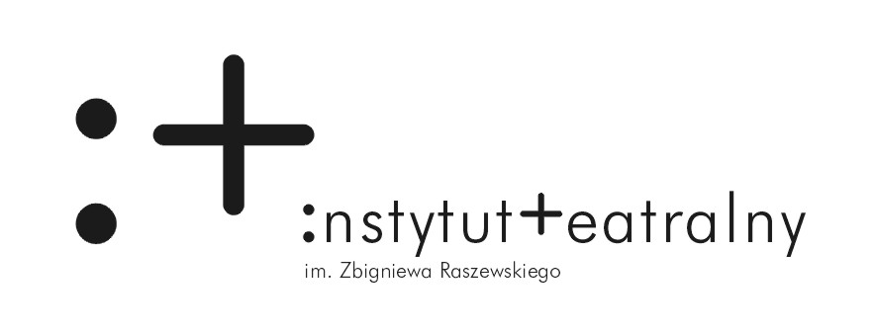

CALL FOR SUBMISSIONS - INTERNATIONAL WORKSHOP
SharedSpace: Weather
14th - 16th November 2014, Warsaw, Poland
Are you a scenographer, performer, architect or theorists under 35 years old?
Are you interested in the contemporary scenography, new forms of space and performative environment?
Zbigniew Raszewski Theatre Institute together with The Prague Quadrennial of Performance Design and Space have the pleasure of announcing an open call for submissions for an international workshop titled SharedSpace: Weather. Discover unknown, mysterious environments, weather as potential, uncertain and transient element of designing space.
Collaborate with Polish and international artists and curators like, among others, Agnieszka Jelewska (Ph.D., Adam Mickiewicz University in Poznan, curator of Polish exhibition for PQ15) and Mike Pearson (Professor of Performance Studies in the Department of Theatre, Film and Television Studies, Aberystwyth University).
SharedSpace: Weather will take place in Warsaw from 14th to 16th, November 2014
Submit your CV and cover letter until 20st September 2014 by sending an e-mail entitled SharedSpace: Weather to anna.galas@instytut-teatralny.pl.
ATTENTION: The meeting will be held in English. The number of places is limited. Travel costs from Europe and accommodation in Warsaw will be covered by the organizer only for selected participants.

This workshop is a part of the SharedSpace: Music Weather Politics 2013 - 2016 project in cooperation with the Prague Quadrennial of Performance Design and Space.

Music, Weather, Politics is the central thematic framework of the international scenography research and artistic project SharedSpace: Music Weather Politics 2013 - 2016, aiming to create platform for exploration, redefining and creating, performative environments. Organized by the Prague Quadrennial and 13 international institutions, SharedSpace: Music Weather Politics 2013 - 2016 is open for all scenographers, theatre-makers, architects, theorists, art professionals, students and wide public. Symposia, exhibitions and educational modules will be held in 11 European countries intensively, with the culmination point at Prague Quadrennial of Performance Design and Space 2015.
www.sharedspace.cz

SharedSpace: Music Weather Politics 2013 - 2016 is organized by the Prague Quadrennial in cooperation with:
Finnish National Gallery, Museum of Contemporary Art, Kiasma Theatre; New Theatre Institute of Latvia; Santarcangelo dei Teatri; Victoria and Albert Museum; HKU Theatre, University of the Arts, Utrecht; Theatre Faculty of the Academy of Performing Arts in Prague; The Royal Central School of Speech and Drama; Centre for Creative Actions IMPACT Macedonia; Center for Polish Scenography, Silesian Museum; Zbigniew Raszewski Theatre Institute; Norwegian Theatre Academy/Østfold University College; The Swiss Arts Council Pro Helvetia; School of Visual Theatre Jerusalem.

With the support of the Culture Programme of the European Union.

